1. For this project you will need to create seven classes. Add these classes as separate files within your project (do not put them in the same VB file as your main subprocedure)
2. The parent class is called Device and has the following fields: Brand (string), Model (string), Operating System (string), IP Address, and MAC address (string).
3. Computer will have one additional field: ISP (string) which represents the internet service provider.
4. Mobile will have two additional fields: WirelessProvider (string) and CellNetwork (string).
5. The two child classes of Computer are Desktop and Laptop.
6. Desktop has the following fields: Monitor (string), Keyboard (string), and Mouse (string). These strings will represent the part numbers of each peripheral.
7. Laptop has the following fields: Screen Size (double) and Touch Screen (Boolean).
8. The two child classes of Mobile are SmartPhone and Tablet.
9. SmartPhone will have a field named PhoneNumber (string).
10. Tablet will have a field named VoIPApp (string)

A class diagram may help visualize the relationships.

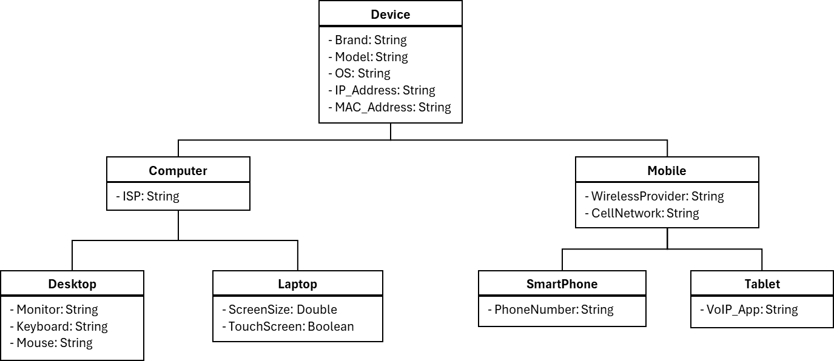

1. All fields of your classes must be private. So, you will use properties to get and set the fields.
2. You must implement the concepts of modularity discussed in this course. Overly redundant code will lose points.
3. Your program is to ask the user how many of each device they want to order. Display a menu to them to purchase Desktops, Laptops, Smartphones, and Tablets.
4. Desktops cost $2000. Laptops cost $800. Smartphones cost $600. Tablets cost $450.
5. The fields of each device will be automatically generated by your program (using random numbers). See the last page for more details.
6. The devices being created for the order are to be added to a List (of Devices). So if the user asks for 6 laptops, you will create a loop that creates 6 Laptop classes and add each to the aforementioned list. Do allow numbers below 1.
7. When the user selects “Complete Order” in your menu, the program will calculate the total cost and display it to the user in the console.
8. The program will then write the device’s information to a text file. Create a separate file for each device type (Desktops, Laptops, Smartphones, and Tablets). On the last lines of each file, there should be an amount (how many devices) and subtotal for those devices. A fifth text file will include how many of each device was ordered, the subtotals, and a grand total of the order.
9. Your menus should continue to loop if invalid input is provided. Error messages are to be displayed in red to alert the user of invalid input.

Example I/O:

===================

Device Order Page

===================

Please select a device to order:

1. Desktop

2. Laptop

3. Smartphone

4. Tablet

5. Complete Order

Choice: 0

Invalid choice. Please try again.

Please select a device to order:

1. Desktop

2. Laptop

3. Smartphone

4. Tablet

5. Complete Order

Choice: 2

How many Laptops would you like to order?

Amount: 6

Please select a device to order:

1. Desktop

2. Laptop

3. Smartphone

4. Tablet

5. Complete Order

Choice: 5

Your order has been completed. Your grand total is $4,800.

Example Output Files for Devices:

Example Output File for Grand Total:

1. The list of possible strings for predetermined fields are below. **Users WILL NOT select these items.** Your computer will generate a random number, and that random number will determine the brand, operating system, wireless provider, cell network, etc. I do not care if a Google Phone gets matched with iOS.

**Brands**

Computer: Acer, Dell, HP, Apple

Mobile: Samsung, Apple, Motorola, Google

**Operating Systems**

Computer: Windows, Linux, Unix, macOS  
Mobile: Android, iOS

**Mobile**  
Wireless Providers: T-Mobile, Verizon, AT&T

Cell Network: 4G(LTE), 5G

**Computer**

ISP: Comcast, Verizon

**Laptop**

Voice over IP Apps (VoIP App): Google Voice, Skype, WhatsApp, Zoom

Example for operating system:

Windows = 1, Linux = 2, Unix = 3, macOS = 4

Generate a random number between 1 and 4. Based on the number, you know what OS to assign.

1. IP Addresses will be randomly generated and have the form of ###.###.###.### where ### represents a number 0 to 255 inclusive. So, generate 4 random numbers and concatenate them with 3 periods.
2. MAC addresses consist of 6 sets of two-digit hexadecimal numbers separated by colons. The digits of hexadecimal numbers can include A through F. For example: 00:1A:3F:F1:4C:C6.   
   10=A, 11=B, 12=C, 13=D, 14=E, 15=F  
   So, generate random numbers 0 through 15. If the number comes out to be 10, concatenate an A instead. If the number comes out as 13, concatenate a D instead. Etc.
3. Model numbers (Device Model, Monitor, Keyboard, Mouse) consist of 18 random characters, consisting only of A-Z and 0-9 characters.